**Organizing Your Work in Jira: Labels, Components, Versions & Templates**

**1. Using Issue Labels and Priorities to Organize Work in Jira**

In Jira, **Labels** and **Priorities** help teams **categorize, filter, and quickly identify work** across projects.

**1.1 Issue Labels**

**Labels** are user-defined tags added to issues.

**Key Characteristics:**

* Text-based
* Multiple labels per issue allowed
* Useful for searching and reporting
* No admin access required

**Examples of Labels:**

* frontend
* backend
* urgent
* testing
* release_1

**Hands-On Lab: Add Labels**

1. Open an issue
2. Locate **Labels** field
3. Type label name → press **Enter**
4. Save issue

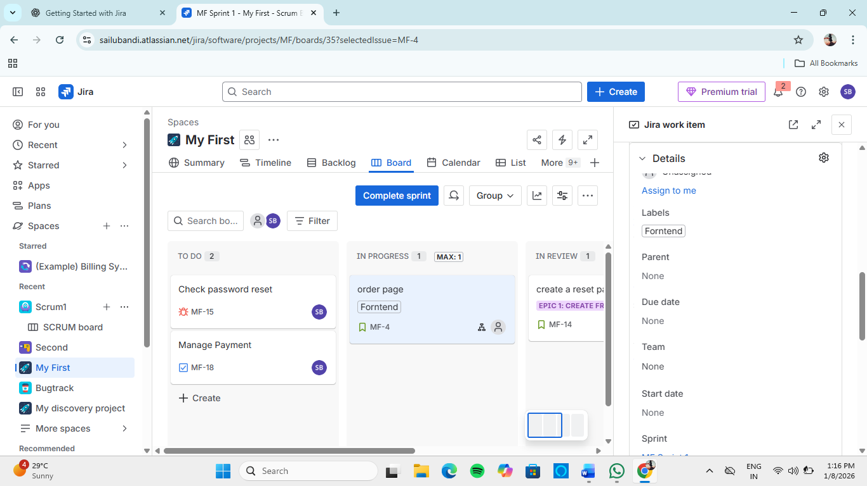

**1.2 Issue Priorities**

**Priority** indicates the urgency of an issue.

**Default Priority Levels:**

* Highest
* High
* Medium
* Low
* Lowest

**Using Labels & Priority in List View**

1. Open **Issue Navigator**
2. Use filters:
   * Labels = frontend
   * Priority = High
3. Save filter for reuse

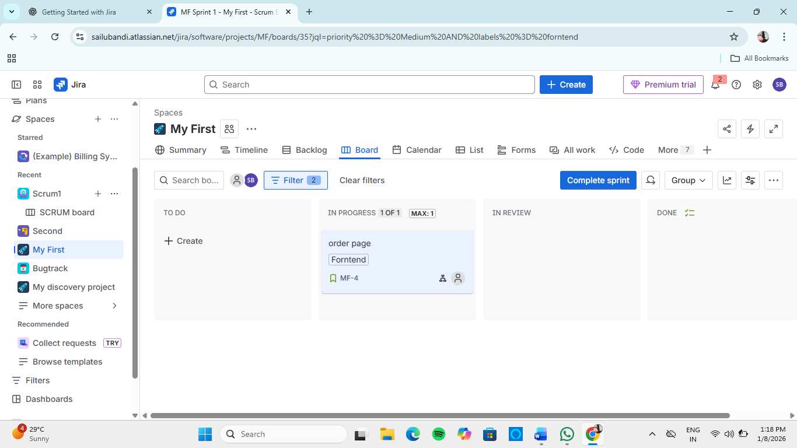

**Professional Tip**

Labels = *classification*  
Priority = *urgency*

**2. Structuring Work with Components in Jira Projects**

**Components** represent **logical parts of a project** such as modules, services, or teams.

**Examples of Components**

* Authentication
* Payment Gateway
* UI Module
* Database
* API Layer

**Why Use Components**

* Assign default owners
* Improve reporting
* Structure large projects
* Reduce confusion in multi-team projects

**Hands-On Lab: Create Components**

1. Go to **Project Settings**
2. Click **Components**
3. Select **Create Component**
4. Enter:
   * Name: User Interface
   * Lead: Select team member
5. Save

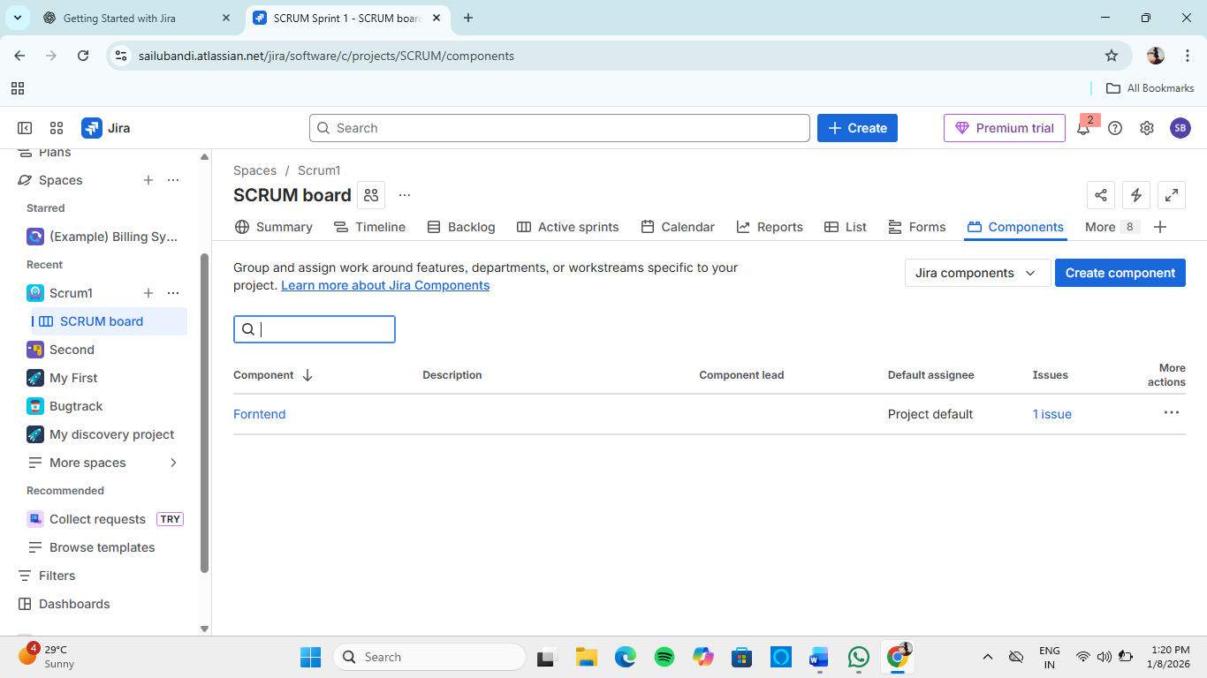

**Assign Component to an Issue**

1. Open issue
2. Select component from **Components** field
3. Save

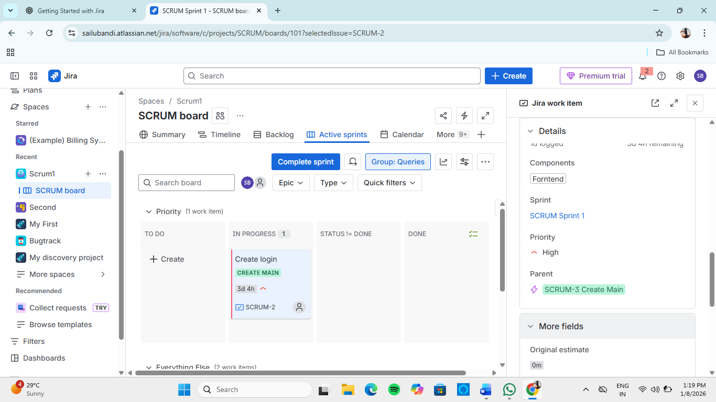

**3. Planning and Releasing with Versions in Jira**

**Versions** (also called **Releases**) are used to **plan, track, and deliver software increments**.

**Types of Version Fields**

* **Fix Version** – Version where issue is resolved
* **Affects Version** – Version where issue was found

**Benefits of Using Versions**

* Track release progress
* Monitor scope creep
* Generate release notes
* Align development with deadlines

**Hands-On Lab: Create a Version**

1. Go to **Project Settings**
2. Click **Versions**
3. Select **Create Version**
4. Enter:
   * Name: v1.0
   * Release date
5. Save

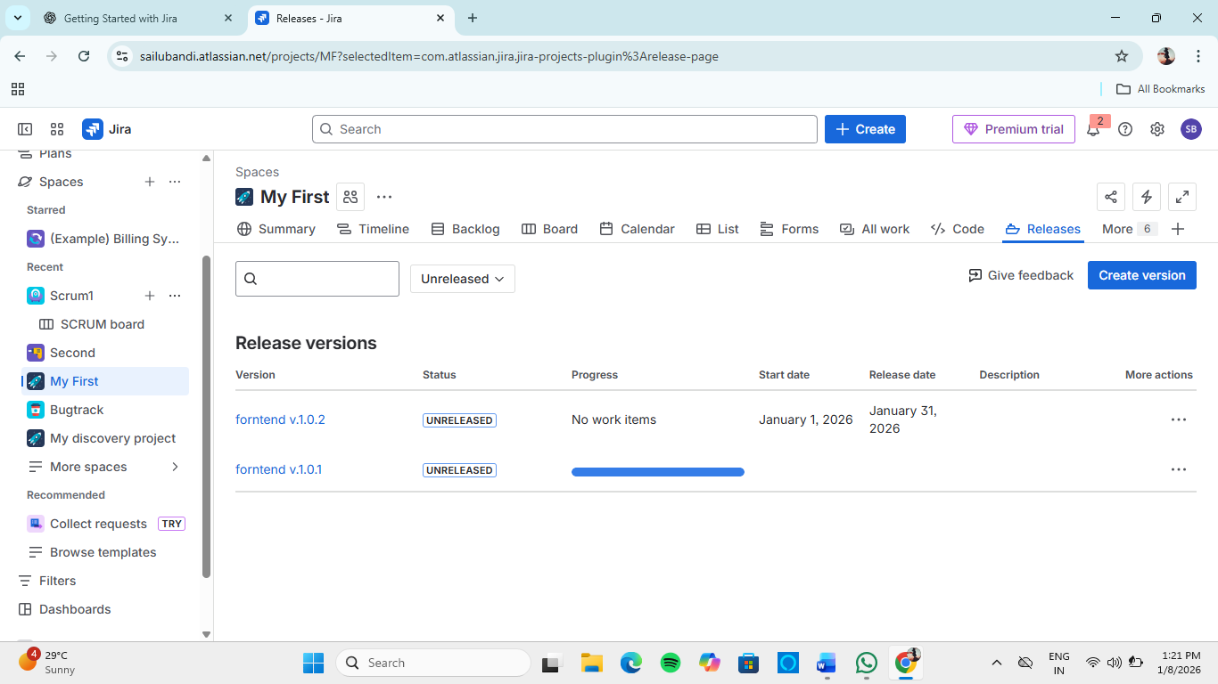

**Release a Version**

1. Go to **Versions**
2. Click **Release**
3. Jira marks all related issues as released

**4. Creating Templates and Reusable Tasks for Efficiency**

Templates help teams **avoid repetitive work and maintain consistency**.

**4.1 Issue Templates**

Issue templates define:

* Standard summary
* Description format
* Default fields

**Common Use Cases:**

* Bug reporting
* Feature requests
* Testing tasks

**Sample Bug Template**

Summary: [BUG] <short description>

Description:

Steps to Reproduce:

Expected Result:

Actual Result:

Environment:

**4.2 Reusable Tasks via Cloning**

**Cloning** creates a copy of an existing issue.

**Hands-On Lab: Clone an Issue**

1. Open an issue
2. Click **More → Clone**
3. Modify summary if needed
4. Save cloned issue

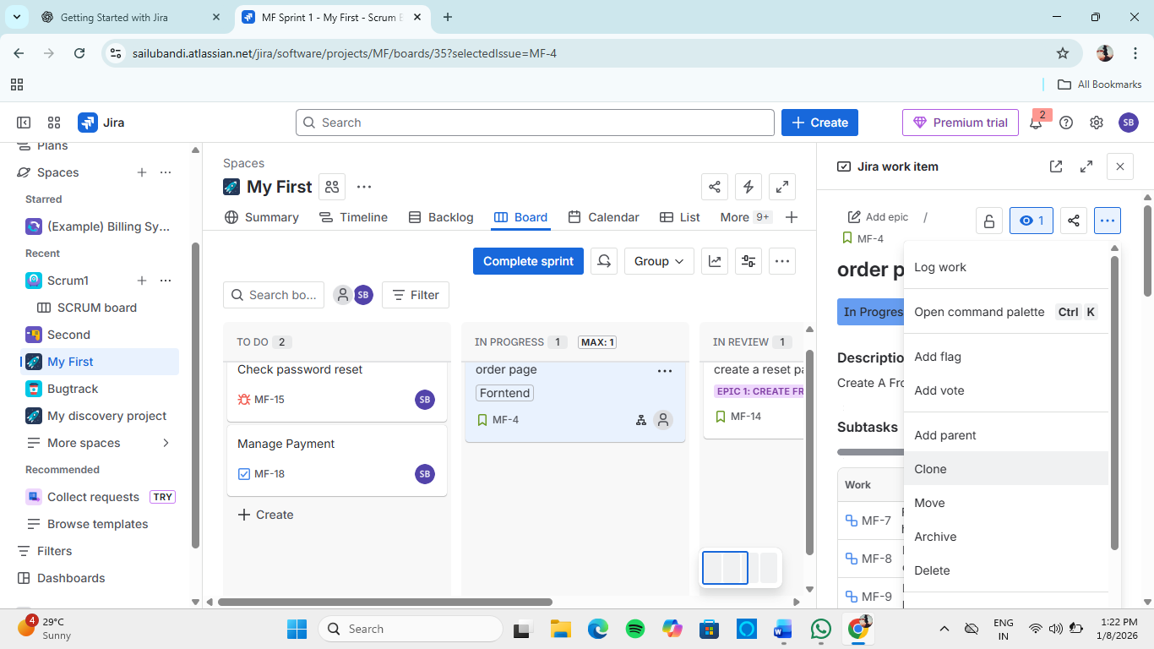

**5. Best Practices for Organizing Work in Jira**

✔ Use **labels** for flexible tagging  
✔ Use **components** for structured modules  
✔ Use **versions** for release planning  
✔ Standardize work using **templates**  
✔ Combine filters + dashboards for visibility

**6. Learning Outcomes**

After this module, the learner can:

* Organize issues using labels and priorities
* Structure projects using components
* Plan and manage releases with versions
* Improve efficiency using templates and cloning

